Date 10/06/2016

Overall Summary:
Project details
Project name: | Barney Craig – River West Allen
Contact name: | Andrew Edwards
Contact team: | Environment Management Wear and Tees
Area Environment Manager: | Fiona Morris
Water body summary information
Water body name: | River West Allen from Source to Wellhope burn
Water body id: | GB103023074680
Water body type: | Surface water
Catchment: | River Allen / River South Tyne
RBP Measure | Mine water treatment
RFF database | Zinc, Cadmium
Related catchments | - GB103023074700 – West Allen from Wellhope burn to Allen  - GB103023074720 – Allen from West Allen to South Tyne  - GB103023075710 – South Tyne from Allen to North Tyne
Water body classification
Surface water body classification | Status (2009) | Status (2015) | Elements failing
Ecological Status | Moderate | Good
Biological Status | Moderate | High | Fish(2009)
Specific Pollutants | Moderate | Fail | Zinc (2009+2015)
Chemical Status | DNRA | Moderate | Cadmium, Lead
Groundwater Body | Name/ID | Status | Elements failing
Groundwater Body | Tyne Carboniferous Limestone and Coal Measures / GB40302G701500 | Poor | Chemical dependant Surface water body status.  General Chemical Test.
No data is available for Fish classification in 2015.
The West Allen from source to Wellhope burn has been misclassified on the catchment planning system showing it as good status, however, metals have been missed from the classification tool giving a false positive. The status given above shows the correct failures.

Summary of impacts from abandoned mines
NoCAM result: | Impacted | Score = 14
SWMI Fail (confirmed) | At risk

Mining Waste Directive
MWD inventory
URN | Site name | Mine type | Reason | Easting | Northing
1029 | Coal cleugh | Metalliferous | Water Pollution | 380091 | 545093
1001 | Barney Craig / Scraithole mines | Metalliferous | Water Pollution | 380348 | 546963

Synopsis of catchment characterisation
 | Details | Comment
Summary of impacts | There are 3 known point sources discharges to the West Allen at Coal Cleugh, Scraithole and Barney Craig. There is significant contribution in wet weather from the tailings dam and dressing floor at Carrshields and Coal cleugh, there is also significant remobilisation of sediment in high flow conditions.
# water bodies impacted | 4
Length of river impacted (km) | 35km | The River West Allen is not the only source of metals for the downstream water bodies, but is a significant contributor.
Metals failing current EQS | U/s Mohope burn / Hindley Wrae (x EQS)  Zn = 67 / 13  Cu = 0.2 / 0.2  Cd = 39 / 8.32  Pb = 1.85 / 1.32  Ni = 0.34 / .26 | Compliance point used for the study is Hindley Wrae ford in the d/s catchment (West Allen from Wellhope to Allen). However, samples have been collected at Sample point ‘West Allen u/s of Mohope burn’ for WFD purposes and have been included on the left this forms the compliance point for the ‘West Allen source to Wellhope burn’ catchment. However this sample point did not form part of the ‘official’ Characterisation.
Metals failing bioavailable EQS | Zinc, Lead, Cadmium
Is there an outbreak risk? | Potential collapse of tailing dam; the retaining wall is in a state of disrepair and during recent flood events has further collapsed.  The bricked up adit at coal cleugh may open up, with an on known quantity of water/ ochre and or spoil behind it. Although there is a small flow from it currently. | Work is underway to reduce the likelihood of retaining wall collapse. A more refined characterisation has also looked to quantify the discharge from Coal cleugh adit.
# of sources | 3 point sources, 4 diffuse inputs. | I have included the tailings dam as a diffuse source. There are also significant diffuse sources at Coal/Alston cleugh and spoil heaps on the left bank opposite the tailings dam. Remobilisation of sediment is the fourth diffuse source.
Metal loading – point sources (tonne/yr) | Zn = 2.836 – 3.830  Cu = 0.00073 – 0.00109  Cd = 0.00365 – 0.00474  Pb = 0.00 – 0.00  Ni = 0.00803 - .01058
Metal loading – river (d/s) | Zn = 0.584 - 18.097  Cu = 0.0018 – 0.000  Cd = 0.00219 – 0.045  Pb = 0.000 – 0.346  Ni = 0.00219 – 0.00945 | Compliance point used is Hindley Wrae ford in the d/s catchment.
How many sources need to be treated to achieve EQS (good status)?
Length of river improved by treatment (km) | 14.5km  41km | Dependant on the cost  benefit used as below.
NWEBS benefit (£m over 25 years) | £2.6m  £7.5m | These are the benefits realised (BAG) for Water quality improvement in the West Allen from source to Wellhope burn and Wellhope burn to Allen. There is a separate benefits assessment relating to the Tyne sediments of which these discharges and inputs play a key part.  These are the benefits realised (NWEBS) for all impacted water bodies downstream of the inputs up to and including the South Tyne.
Potential contribution from others?

Recommendations
Options | Comment
SWMI review
Confirmed pollution from metal mines: | Recommend for source apportionment study, and identify monitoring locations.
Source apportionment study
Monitor:
sources not defined, more monitoring needed
Feasibility:  sources defined, pass to Coal Authority for scoping stage | - The main sources of Zn and Cd are:  - Barney Craig (dry weather)  - Tailings dam (Wet weather)  - Sediment remobilisation (Wet weather)  - Pb arises from three main  - diffuse sources:  - MWD site 1029 Coal cleugh  - Tailings dam  - Sediment remobilisation  - Scoping study should focus on:  - Barney Craig mine water  - Carrshields tailings dam  - Coal cleugh adit
Suspend:
sources too complicated, not feasible with current technology/costs
National delivery team decision |  | Priority

Introduction and site map(s) (OS 1:25,000)
West Allen from source to Wellhope burn is an uplands catchment with a history of mining activity and flows for 9km before meeting the Wellhope burn which brings further potential mining inputs although concentrations are lower than the West Allen. The WFD compliance point for the catchment is upstream of Wellhope burn, known as ‘West Allen u/s Mohope burn’ and is sampled for WFD classification but was not incorporated into this characterisation.

The decision was taken not to use ‘West Allen u/s Mohope burn’ (shown in the figure 4 below as waterbody compliance point) because of time constraints and the necessity to gather a full round of samples in one day. The compliance point used in the study is Hindley Wrae ford which is the compliance point for the d/s water body as shown in the map below. At this point it is expected to see a greater degree of improvement following any treatment interventions. The maps below show the catchment location in the North East Area setting and within the South Tyne. Red lines indicate waterbody boundaries and pink spots show sample points locations

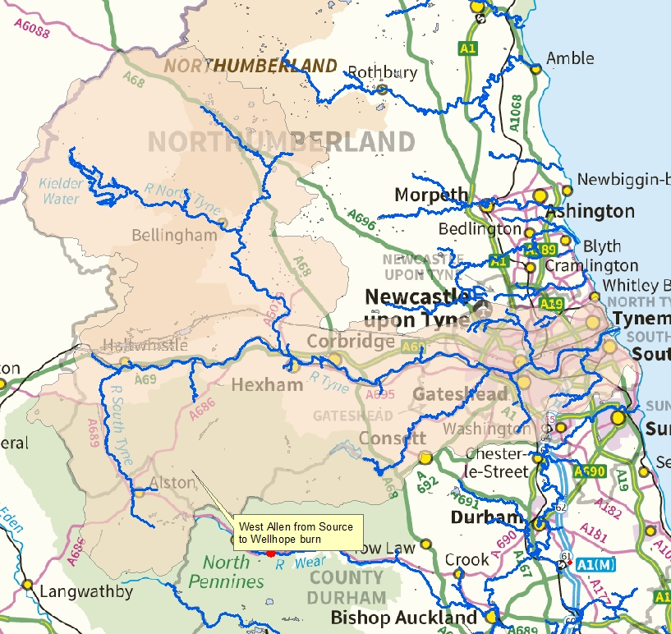
Figure 1 - Overview of the North East river system

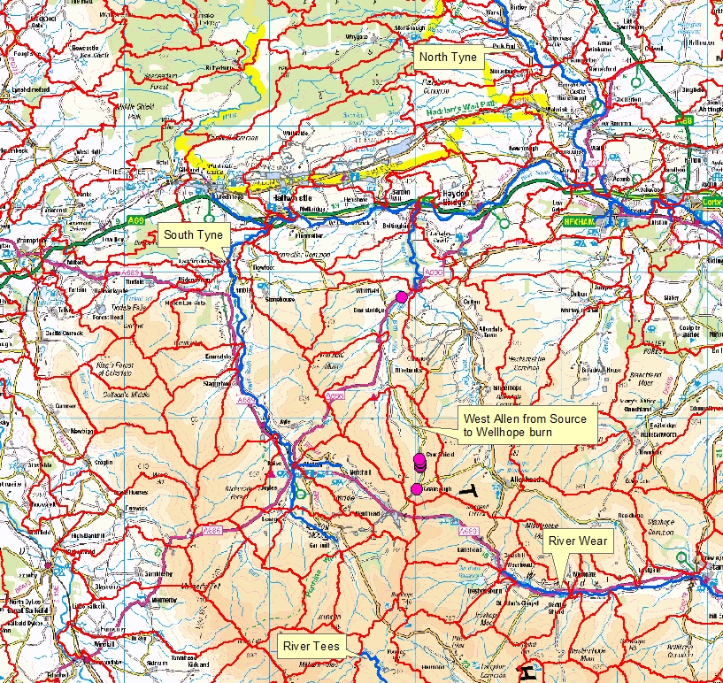
Figure 2 - Overview of catchments on the South Tyne river system

This study aims to characterise the catchment, identifying the sources of pollution as well as quantifying the impact of some of these sources on the waterbody and identify the most polluting sources.

Below are a series of maps showing the sample points used for the study, the pink coloration shows spoil heaps and the dark red dots are the locations of sites that have been identified under the Mining Waste Directive as causing water pollution.

Monitoring points
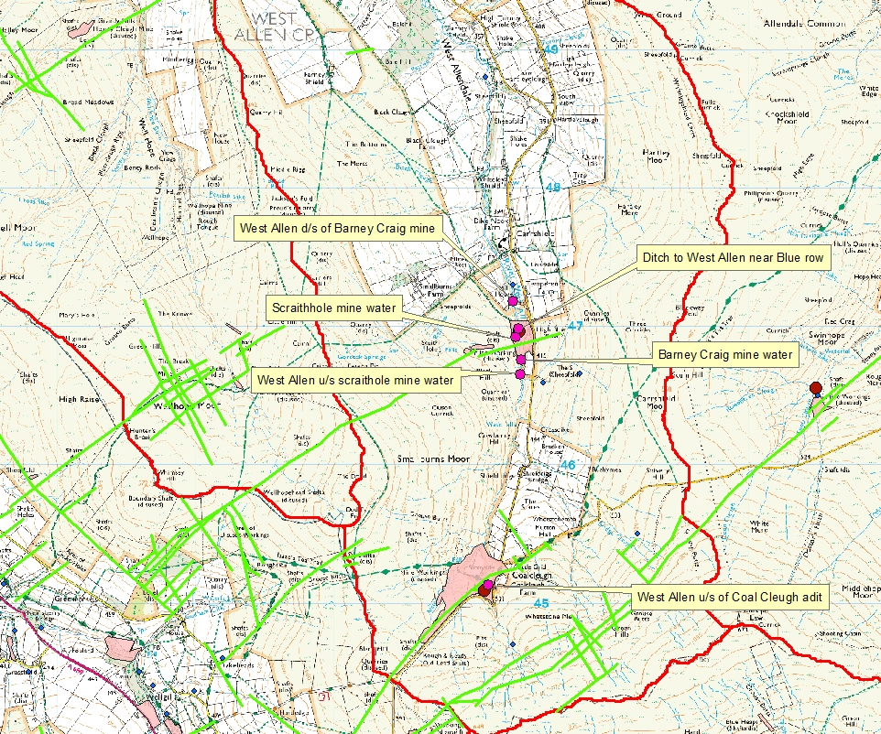
Figure 3 - Sample points in the upper catchment

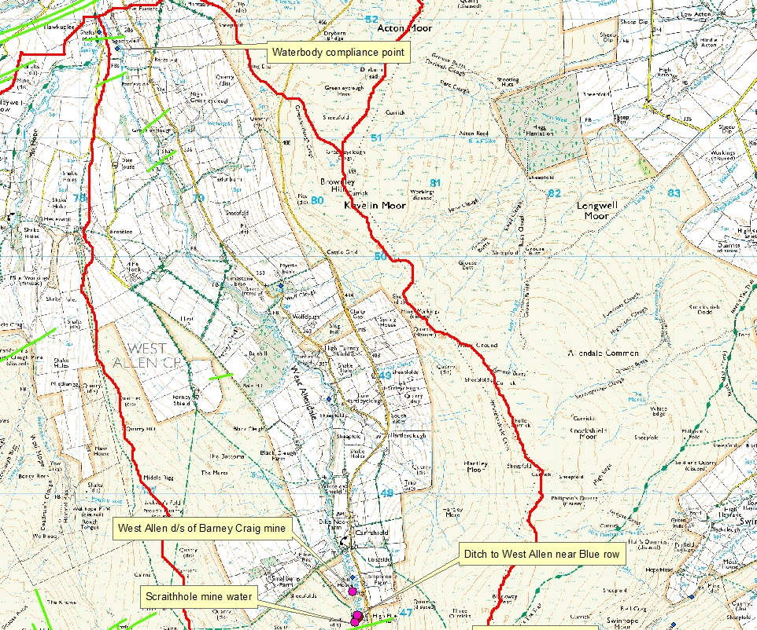
Figure 4- Sample point in relation to the waterbody compliance point

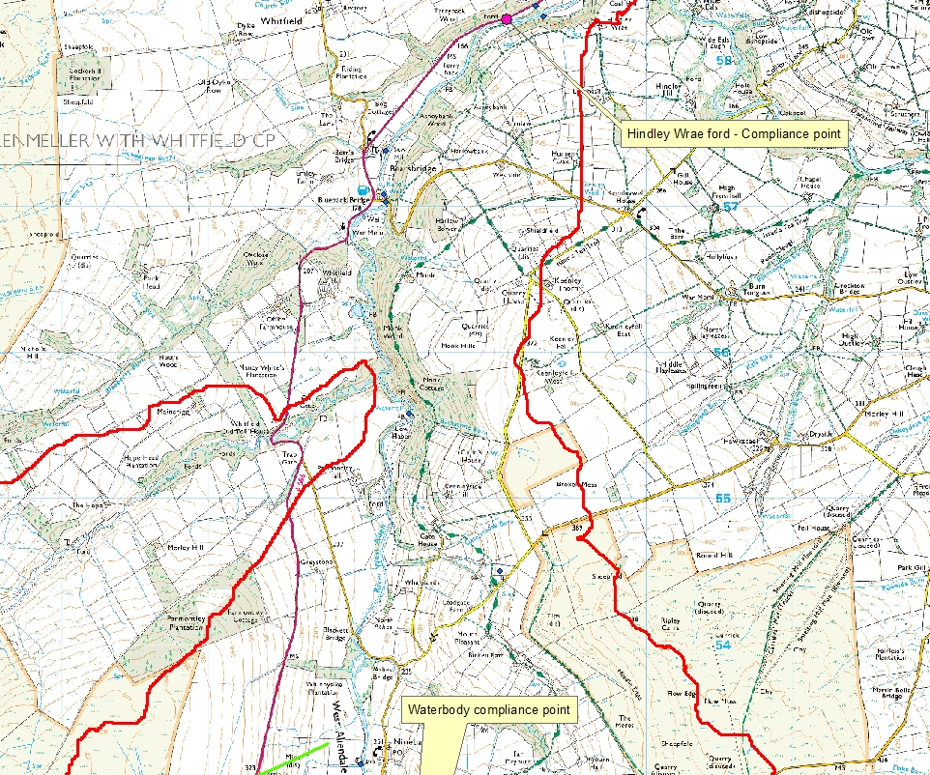
Figure 5 - Sample point used as the compliance point for this study

Review of historical data and information
There are 3 mines in this catchment, Barney Crag, Scraithhole and Coal cleugh, all of which have associated spoil and dressing floors. Barney Crag mine was opened in around 1760 and was mined through to the 19th Century for Lead and Zinc. Scraithole mine worked the veins on the western side of the valley from around 1820 and has operated sporadically until 1981 when it was finally worked for Zinc and Witherite. Associated with these two mines are various ages of dressing and processing floors in differing states of repair most notably the wall which retains these features is slowly collapsing as heavy floods wash parts of it away. This retaining wall also provides one side of a tailings facility which has been filled to well above the level of the wall.

Coal cleugh mine was operated from early 16th Century until around 1830 as a lead mine and has since been worked for Zinc and Fluorspar. There are associated spoil heaps and dressing floors located at Coal cleugh as well and workings at the head of Alston Cleugh are littered with spoil heaps and shafts from mining efforts through the years.

Geological setting and map
Much of the valley floor of the West Allen from source to Wellhope burn, including the West Allen River, is underlain by a limestone geology whereas the upper catchment and area higher on the valley sides are more formed on mudstone with some bands of sandstone such as the firestone sill.

The West Allen forms part of the Alston mining block which consists of a dome of ‘Weardale’ Granite overlain with thick limestone capped with sedimentary sandstones and mudstones. The limestone has fractured in multiple directions allowing hot mineral rich water to flow and leave ore deposits in many veins as it cooled. The ore body has a number of zones radiating out from the central source of mineralisation with zinc and lead more prominent towards the centre and Barium and Fluorite further out. The limestone geology buffers acid produced when sulphide minerals oxidise, resulting in the mine waters discharging being close to neutral ph.
The maps below show the geology of the catchment and the downstream catchment “West Allen from Wellhope burn to Allen”. The pink dots show the sample points used in this characterisation and generally the blues represent limestone formations, and the orange and yellow coloration represents formations that are dominated by sand or mudstone.

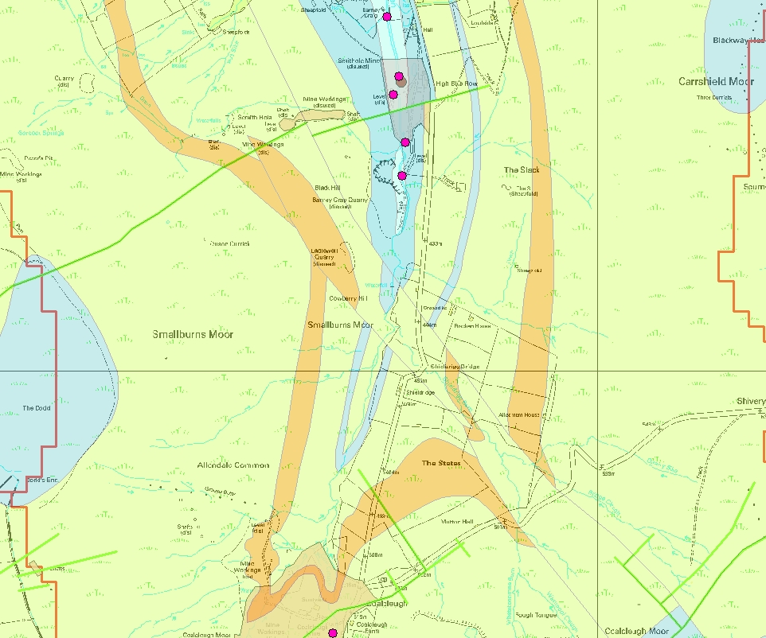
Figure 6 - Geology of the upper catchment
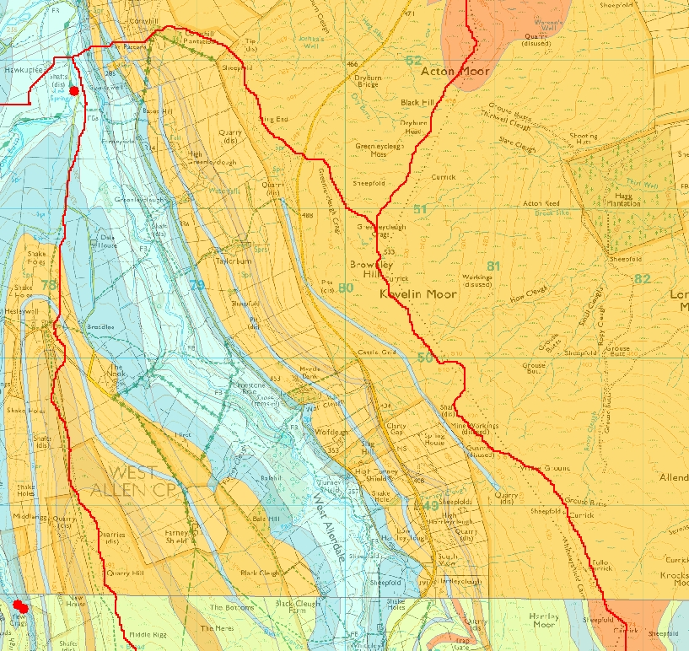
Figure 7 - Geology of the lower catchment
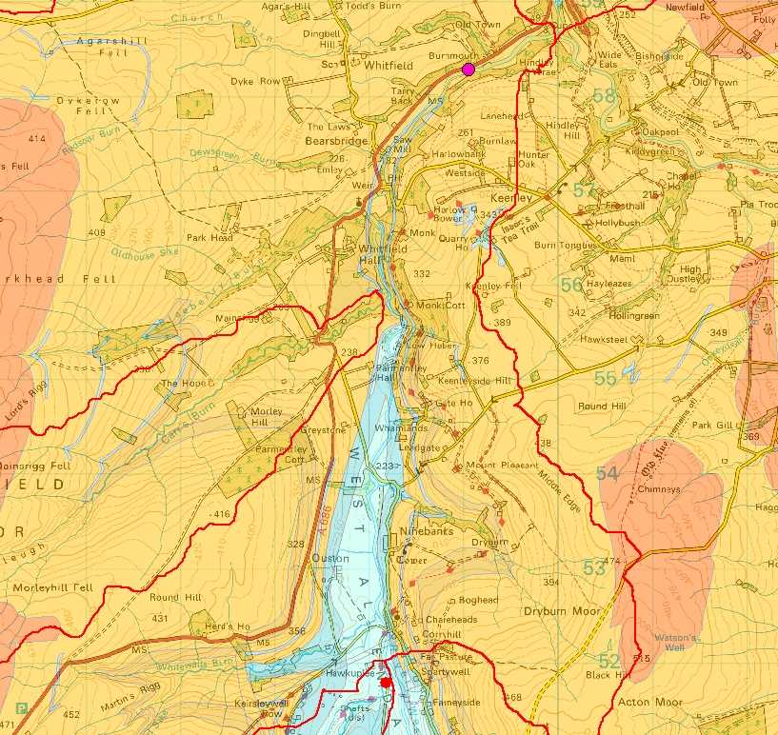
Figure 8 - Geology of the downstream waterbody
Biological / ecological info
The West Allen from Source to West Allen is currently classified as High for Invertebrates and Macrophytes based on 2015 data.
This is further backed up by biological monitoring that was carried out by AECOM in 2014 in this catchment, the findings across 8 sample sites throughout the catchment showed that macro invertebrate data reached good or high status at all sites in all seasons. The 8 sites included locations both upstream of mining impacts and directly downstream of mining impacts. It also included sites in the downstream water body, West Allen from Wellhope burn to Allen and a site in Wellhope (Mohope) burn. The report concluded that “Overall, the macro invertebrate communities observed for this catchment across the three seasons did not show a consistent pattern of response to heavy metal concentrations moving downstream”.

Landowners / occupiers
The majority of this catchment is owned by Allendale Estate. There may be small parcels of land within the valley outside of this ownership but no contact has been required with these land owners.

Stakeholders and discussions to date
Natural England
The mine site is a Scheduled Ancient Monument, discussions have been held to establish what would be acceptable development on the mine site. They have been involved in discussion to install drainage on the site and regarding repairs to the retaining wall and tailings facility.

There have been discussions about the use of the moorland opposite to accommodate a treatment scheme as it carried various designations, the outcome of these discussions being that no development can take place because of the blanket bog on the site.

Northumberland County Council
Discussions relating a drainage channel and flood risk

North Pennines AONB partnership – Allen Valleys Project
Some partnership working with the Tyne Rivers Trust to address the upper section of the retaining wall and spoil heaps on the left bank.

Tyne Rivers Trust (TRT)
Some partnership working with NPAONB partnership as described above. TRT have also carried out diffuse intervention works at Coal cleugh and Alston cleugh

Allendale Estates
Discussions about availability of land for a treatment scheme to be sited.

Conservation and heritage designations
There are various designations within the catchment which are shown on the maps below, the details of each designation can be found in Appendix 1.

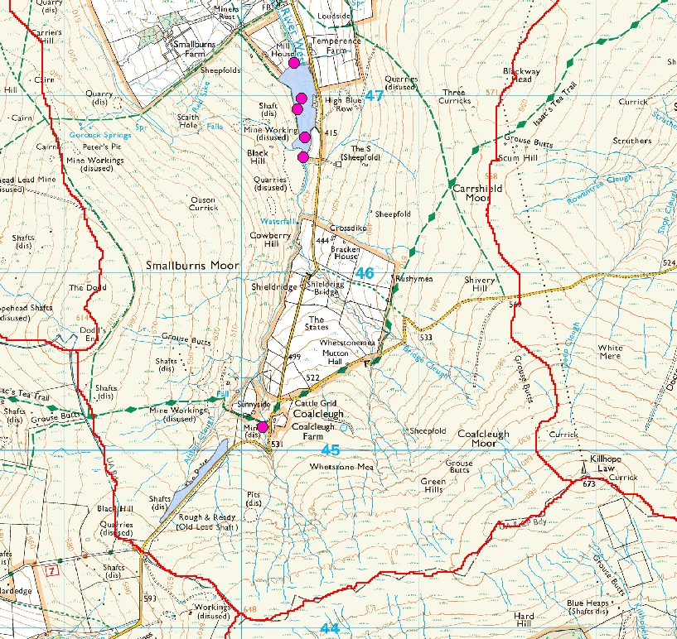
Figure 9 - Scheduled Ancient Monuments (SAM)

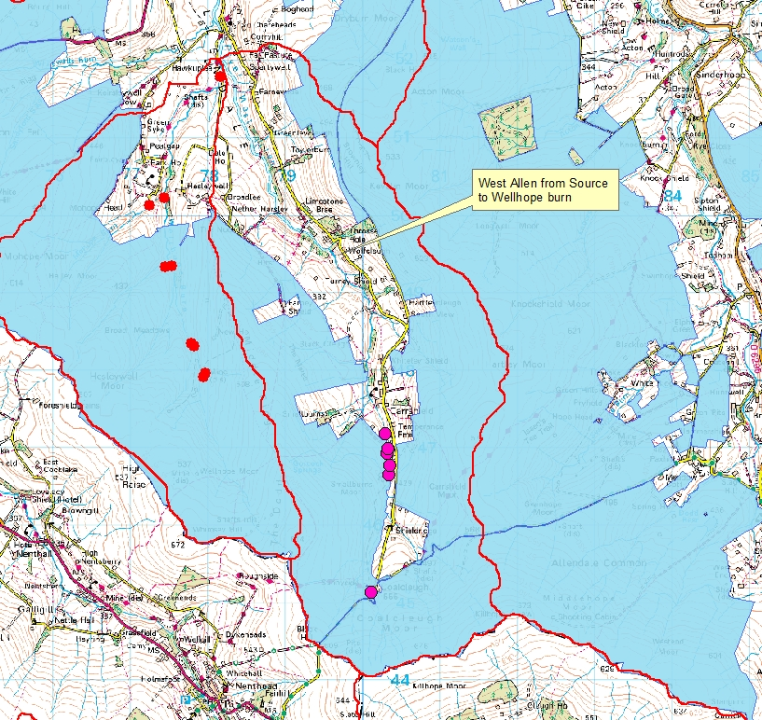
Figure 10 - Special Protection Area (SPA)

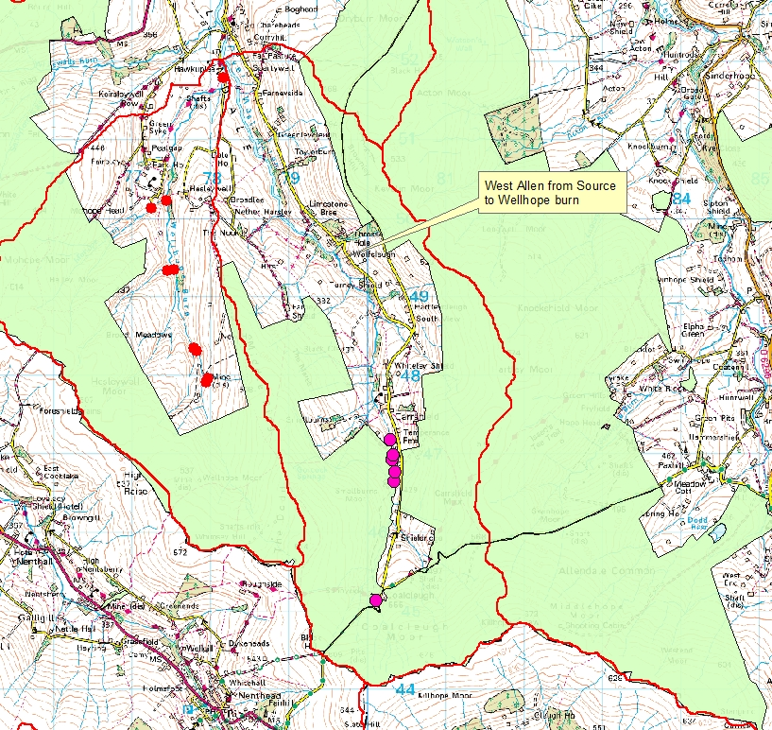
Figure 11 - Special Area of Conservation (SAC)

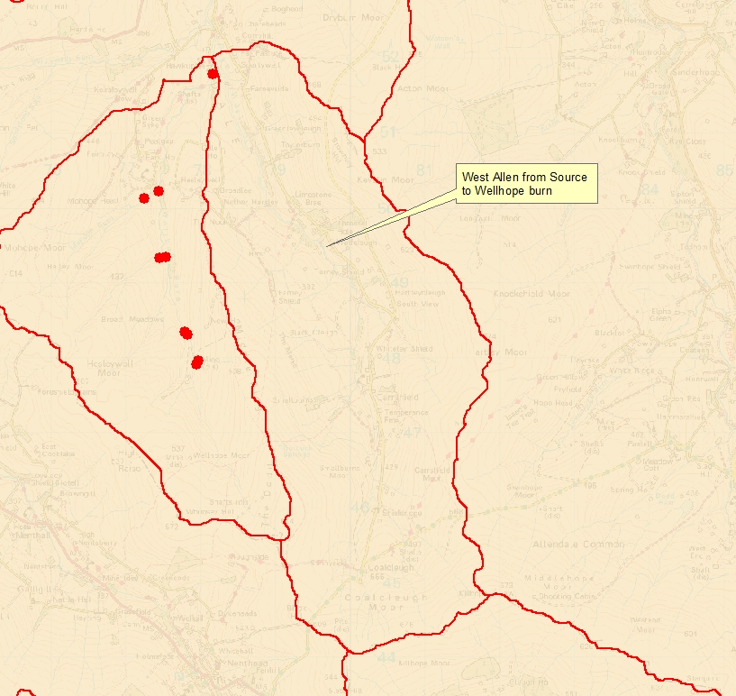
Figure 12 - Area of Outstanding Natural Beauty (AONB)

Monitoring programme
A monitoring programme has been in place on the West Allen around the Barney Craig discharge since May 2012, however, there was no flow monitoring on the Barney Craig adit and the most downstream sample point was WA2. In January 2014 flow monitoring became available for the Barney Craig discharge and an additional sample point was included at Hindley Wrae ford, WA1, the monitoring programme shown below in table 1 was then carried out over a period of 12 months. The data included in this report focuses on the data gathered in 2014 as it is the most comprehensive and up to date data set.

Location | Short ref | Gauge type | NGR | Sample suite
West Allen at Hindley Wrae ford | WA1 | EA gauging station | NY 79050 58580 | METSTR
West Allen d/s Barney Craig mine site | WA2 | Velocity area | NY 80300 47180 | METSTR
Ditch to West Allen near Blue Row | WA3 | Velocity area | NY 80340 46980 | METSTR
Scraithole adit | WA4 | Bucket and stopwatch | NY 80320 46920 | METPR
Barney Craig adit | WA5 | CA logger | NY 80360 46760 | METPR
West Allen upstream scraithole | WA6 | Velocity area | NY 80350 46650 | METSTR
Coal cleugh downstream Coal cleugh adit | WA7 | Velocity area | NY 80120 45130 | METSTR
Table 1 - Sample point details

Analysis Suite | Field Determinants |  | Laboratory Determinants | Metals (Dissolved and Total)
METSTR  for surface waters | pH, EC, DO, Temperature |  | Dissolved Organic Carbon  Suspended Solids, Hardness as CaCO₃,  pH, Alkalinity @ pH4.5,  Cl, NO₂, NH₃, SiO₂, SO₄ | Al, B,  Ba, Ca,  Cd, Cr,  Cu, Fe,  K, Li,  Mg, Mn,  Na, Ni,  Pb, Sr,  Zn
METPR  for adits | pH, EC, DO, Temperature |  | EC, DO%,  Hardness as CaCO₃,  pH, Alkalinity @ pH4.5,  Cl, NO₂, NH₃, SiO₂, SO₄
Table 2 - Analysis suites
Samples were gathered at a range of flows, with Q values taken from the gauging station at Hindley Wrae ford, shown below in figure 13 starting from upstream to downstream, the distances from WA7 to WA6 and WA2 to WA1 are sufficiently far apart that there is not likely to be any impact on the downstream sample point from any disturbances at the upstream point however, the remainder of the samples do have the potential to have been impacted by disturbances in the upstream sample points, however this is not thought to be significant.

As highlighted in the conceptual model (figure 14) there is potential for input of metals downstream of the mine site, particularly from Wellhope burn, however it is thought that the majority of inputs occur in the upper part of the catchment, above the and through the mine site.

The diffuse spoil inputs shown on the conceptual model are not representative of the scale of the input, they are to indicate presence of diffuse sources only. Likewise the point sources are not representative of scale.
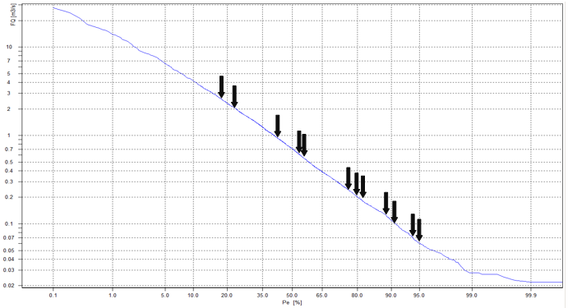

Figure 13 - Q values

Conceptual model

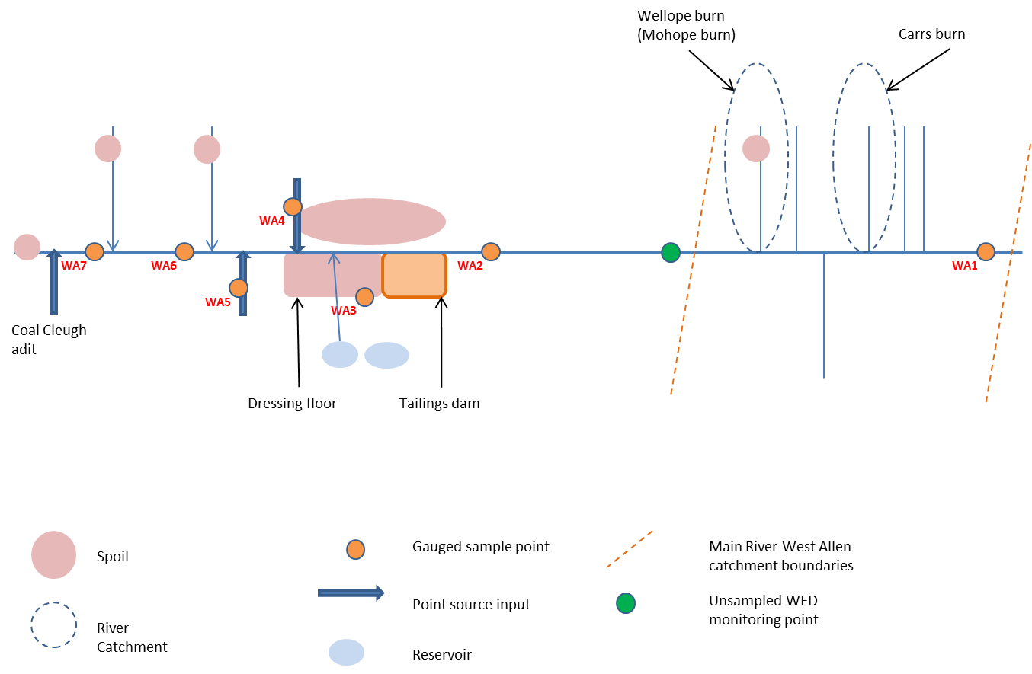
Figure 14 - Conceptual model of the West Allen
Flow
 |  | Flow balance (l/s)
Date | Q | WA7 | WA6 | % accounted for at WA6 | WA6 + WA5 + WA4 +WA3 | WA2 | % accounted for at WA2 | WA2 | WA1 | % accounted for
06/02/2014 | 18 | 56.0 | 413.0 | 14% | 442.9 | 549.0 | 81% | 549.0 | 2463.0 | 22%
14/01/2014 | 21 | 9.0 | 154.0 | 6% | 171.1 | 205.0 | 83% | 205.0 | 2129.0 | 10%
13/03/2014 | 37 | 6.0 | 49.0 | 12% | 67.4 | 83.0 | 81% | 83.0 | 509.0 | 16%
14/04/2014 | 54 | 7.0 | 53.0 | 13% | 75.0 | 75.0 | 100% | 75.0 | 579.0 | 13%
07/05/2014 | 55 | 7.0 | 53.0 | 13% | 71.1 | 71.0 | 100% | 71.0 | 514.0 | 14%
09/12/2014 | 79 | 9.0 | 74.0 | 12% | 97.0 | 101.0 | 96% | 101.0 | 233.0 | 43%
08/10/2014 | 80 | 16.0 | 66.0 | 24% | 90.7 | 86.0 | 105% | 86.0 | 203.0 | 42%
11/11/2014 | 81 | 18.0 | 115.0 | 16% | 137.1 | 184.0 | 75% | 184.0 | 197.0 | 93%
04/08/2014 | 89 | 1.0 | 23.0 | 4% | 40.2 | 44.0 | 91% | 44.0 | 115.0 | 38%
19/06/2014 | 91 | 5.0 | 29.0 | 17% | 50.2 | 48.0 | 105% | 48.0 | 95.0 | 51%
03/09/2014 | 94 | 1.0 | 22.0 | 5% | 40.2 | 46.0 | 87% | 46.0 | 65.0 | 71%
15/07/2014 | 95 | 1.0 | 13.0 | 8% | 32.2 | 34.0 | 95% | 34.0 | 56.0 | 61%
Table 3 - Measured flows at each sample point

Based on the above conceptual model the following flow balance calculations were used
- WA7 = WA6
- WA6 +WA5 + WA4 + WA3 = WA2
- WA2 = WA1

Table 4 - Flow balances for each main river sample point
West Allen upstream of Scraithole mine (WA6)

The flow balance at this point is limited as there is only one upstream point, and a kilometre or so between the two points. As expected the one sample point does not account for a lot of the flow that arrives at WA6. There are known tributaries in this section of the West Allen that will account for the difference in flow values.

West Allen downstream of Barney Craig mine (WA2)

This section of the West Allen is in relatively close proximity to each other with only 500m between WA6 and WA2. As expected the majority of flow can be accounted for by our sampled points.

The result of 75% on 11/11/2014 at Q81, suggests that there was an unknown input, however it could equally be attributable to error margins in the gauging technique used, on the same date the accountability at Hindley Wrae ford is 93% which is notably higher than on other dates. It is possible that there was rain in the upper part of the catchment which was making its way through the mine site at the time of the gaugings, this is further backed up by the second highest flow being recorded at WA7.

During higher flows, Q18-37, there is a consistent unknown input of water through the mine site, this is likely to be surface water flowing over the surface of the mine site or sub-surface through the spoil or tailings.

There is also a slight reduction in flows accounted for at low flows, this may be because of the fact that flows are low and there may be a greater proportion flowing in the hyporheic zone. It could also be attributable to the gauging method not being best suited to low flow conditions.

Results and interpretation

Table 5 - Summary of concentrations and EQS concentrations
Table 6 - Summary of loadings from each sample point
The table of results above, (Table 5) show a summary of the concentrations measured at each point and table 6 shows the loading summary and how much each point contributes to WA1 and WA2, the two compliance points used for the characterisation. ‘Scraithole’ and ‘ditch to blue row’ are shown to contribute minimal amounts of zinc to WA2 in any flow conditions (1-5% combined) and slightly higher contribution to WA1 (0.5-19% combined). However, this falls into insignificance when compared to the contribution from the Barney Craig adit, ranging from 32-109% contribution to WA2 and 12-461% to WA1.

There is a large input of zinc between WA7 and WA6 which is unquantified, the loading increases on average from 0.7kg/day to 2.1kg/day. In the lowest flows there is actually a decrease in zinc loading between the two sample points, suggesting a point source input upstream of WA7, however, in high flows, the metal load increases from 0.8kg/day to over 8kg/day. There are numerous potential sources between these two points, however, it cannot be defined by this study.

Barney Craig is clearly the most dominant input of Zinc in low flow conditions, contributing a maximum of 109% and 461% to WA2 and WA1 respectively, treatment of this discharge would make significant improvements to these two points in low flow events. However, this pattern is not reflected in high flow events when it only contributes 32% and 12% to WA2 and WA1. The additional zinc is therefore being contributed by other sources and as can be seen below in the mass balance calculations the measured sample points account for close to 100% in all but the highest flows, the most quantifiable of these unmeasured sources is the diffuse input between WA6 and WA2 as all point sources are measured within a 500m stretch, therefore this diffuse input can be calculated by

WA2 - WA3 - WA4 - WA5 – WA6 = WAX7
This calculation was performed for loadings and percentage contributions for each metal, total and dissolved, the results are summarised in table 7 below.

Table 7 - calculated diffuse input from mine site

The minimum figures shown are of little consequence because of the negative values, in reality there is likely to be a small input from the diffuse sources through the mine site in low flows but they are insignificant compared to the measured sample points. The maximum and average figures, however do give some idea of the importance of diffuse inputs from the mine site with 40% of zinc and cadmium being derived from this unmeasured source in high flows. The diffuse sources cannot be distinguished between dressing floor, tailings dam, spoil or groundwater input, however, it does show that interventions are required in this area to allow the EQS to be achieved.
Mass balances

Using the information gathered, and summarised in tables 5, above, the metal loadings were calculated for Zinc (Zn), Cadmium (Cd) and Lead (Pb) using the equations:
- Loading (kg/day) = (Dissolved concentration (ug/l) * flow (l/s)) * 0.0000864

- Loading (g/day) = (Dissolved concentration (ug/l) * flow (l/s)) * 0.0864

The following formula were then used to calculate the mass balances for each main river sample point for each metal:
- WA7 = WA6
- WA6 +WA5 + WA4 + WA3 = WA2
- WA2 = WA1

Table 8 - Zinc mass balance calculations

WA6
The mass balance calculations for WA6 and WA1 are limited in the same way the flow balances were as there is only one upstream sample point available to compare. The contributions of WA7 to WA6 increase as the flows reduce suggesting that additional sources between the two points are mobilised in higher flows. However, the numbers are relatively low and small variations can account for a greater percentage change. The zinc upstream of WA7 is largely attributable to the Coal cleugh adit, as found from a subsequent, smaller study of coal cleugh in 2016, this suggests that the adit is a key input affecting the concentrations at WA6, especially in lower flows.

WA2
The amount accounted for by the measured sample points fluctuates between 85 and 115% in lower flows with no definitive trend, this may be related to general fluctuation in the zinc load through the site. However, when flows increase to around Q37, there is a downward step change in percent accounted for at this point that is maintained through Q21 and Q18 flows. This is consistent with additional sources becoming mobilised in higher flows, which is to be expected due to the nature of the site with spoil heaps and tailings dams lining the watercourse. Barney Craig is consistently the major contributor of zinc through this section of the watercourse. This is backed up by the results in table 6 showing that Barney Craig alone on average accounts for 75% (32-109%) of the Zinc that arrives at WA2.

WA1
There is a clear increase in the amount of zinc that originates upstream of WA2 as the flows decrease with upto 425% of zinc load originating upstream of WA2 In low flow. Conversely in high flows this percentage falls as low as 37%. There are 3 potential sources for this diffuse pollution, sediment re-suspension and remobilisation, surface run off from spoil heaps and input from groundwater. It is likely to be a combination of all of these factors, however. Gozzard, 2008, identified re-suspension and remobilisation of sediment as an important factor in the increase of zinc loading in the West Allen.

Table 9 -Cadmium mass balance calculations

Cadmium largely follows the same trend as zinc at all sample points, however the fluctuations between WA6 and WA2 in lower flows are not as substantial, nonetheless they could still be accounted for by natural variations in concentrations through the site. The figures above in table 9 suggest that there is more cadmium unaccounted for on any given day than zinc which suggests that one of the unmeasured sources through the mine site it contributing a higher percentage of Cadmium to the watercourse. Barney Craig remains the most significant contributor to the watercourse at an average of 60% (22-94%), although it contributes a greater proportion of the Zinc.

Table 10 - Lead mass balance calculations

WA6
The amount of lead accounted for as WA6 is very low in all flow conditions, there are sources between these two points that stick out as being potential contributors, there is a Mining Waste directive site identified at Coal cleugh which identifies the area around the two tributaries at the head of the catchment as contributing significant amounts of Lead Zinc and Cadmium. Almost all of this spoil is located downstream of WA7, this is shown in figure 3 above, the remainder of the lead not accounted for at WA6 is likely to originate from this area.

WA2
The amount of lead accounted for by the measured points between WA6 and WA2 is higher in higher flows, this points towards areas upstream of WA6 contributing a greater proportion of lead in wet weather. However, there are 2 anomalies to this, Q80 on 8/10/2014 was one of the highest flows at WA7 but only 36% is accounted for between WA6 and WA2 suggesting that on this occasion the inputs from the mine site were more significant than is shown in other high flow events (Q80 is taken from Hindley Wrae and is not necessarily representative of flows throughout the whole catchment).
The other anomaly is Q91 on 19/6/2014 with 76% accounted for, the mine site could be expected to have a greater influence on WA2 at lower flows looking at other similar flows. Looking at the flow data, shows this date to be a flow at WA7 similar to Q37 when 77% is accounted for which is similar to what was measured at the Q91 event.

WA1
The lead loadings follow the same pattern as zinc and cadmium, in higher flows the inputs from upstream of WA2 become less significant suggesting re-suspension and remobilisation of lead from sediment

This section of the results and interpretation details nine graphs which show the measured loadings of zinc, cadmium and lead in relation to the site specific EQS load at Q 95, Q55 and Q18 flow conditions, (Q values determine by the flow duration curve for the West Allen at Hindley Wrae Ford, see Figure 13). The site specific EQS is equivalent to the Predicted No Effect Concentration, (PNEC). PNEC have been calculated by using the BLM and PbBLM Tools. These tools use ecotoxicological data and site specific water quality data to produce the PNEC values. PNEC loadings have been calculated by multiplying the metal PNEC by the measured flow. Therefore the “PNEC load” is the target metal loading (concentration multiplied by flow) required to achieve compliance with the EQS. The purpose of the graphs is to show the variation in the actual metal loadings in the River West Allen in comparison to the EQS and illustrate the load of metal that needs to be removed to achieve EQS compliance. Also included in this section is 1 graph per metal to show how the measured and PNEC loads change at Hindley Wrae ford as the flow increases to highlight the input from diffuse sources.

Zinc

Figure 15 - Zinc and PNEC load at each Q value

Figure 16 - Zinc and PNEC load at Q18

Figure 17 - Zinc and PNEC load at Q55

Figure 18 - Zinc and PNEC load at Q95

Figures 15-18 above show measured loadings compared to PNEC loadings, Figure 15 shows that in the very highest flows 40kg/day needs to be removed from the system in order to achieve compliance with the zinc EQS whereas at Q79 only 6kg/day needs to be removed. With Barney Craig inputting on average 7.5kg/day compliance starts to look achievable at Hindley Wrae in lower flows with treatment of once point source.
The other 3 graphs look in more detail at how the loadings change down the catchment. All of them show a marked increase between WA6 and WA2 where the Barney Craig adit discharges, after this point they look very difference, with Q95 flows almost returning to compliance at WA1 where as Q18 continues to rise as it further highlights the additional diffuse inputs downstream of WA2. Even at Q55 more than one treatment option would be required to achieve compliance although the extent of the diffuse pollution downstream of WA2 reduces which would make any interventions more effective. Figure 18 shows that it may be possible to achieve compliance in the vey lowest flows at WA2 which would represent a significant improvement.

The graphs above also show the magnitude of input between WA6 and WA2 in high flows, at Q95 there is an increase of 6kg/day whereas at Q18 there is an increase of 20 kg/day. Equally noticeable is the amount of zinc that arrives from upstream of WA6 in high flows, showing the significant diffuse input this has.

Cadmium

Figure 19 - Cadmium and PNEC load at each Q value

Figure 20 - Cadmium and PNEC load at Q18

Figure 21 - Cadmium and PNEC load at Q55

Figure 22 - Cadmium and PNEC load at Q95
Cadmium
Figures 19-22 above show that Cadmium follows the same pattern as Zinc with loads continuing to increase in higher flows between WA2 and WA1 but falling between these 2 points in lower flows. Equally, the amount of input through the mine site at Barney Craig increases significantly in higher flows, as does the input from upstream of WA6.

Figure 23 - Lead and PNEC load at each Q value

Figure 24 - Lead and PNEC values at Q18

Figure 25 - Lead and PNEC load at Q55

Figure 26 - Lead and PNEC load at Q95

Lead
Figures 23-26 above show that lead does not fail the EQS at Hindley Wrae in higher flows but does fluctuate around the compliance point in lower flows. This is largely because of the increase in Dissolved Organic Carbon (DOC) as flows increase making less of the lead available for uptake by organisms therefore allowing a higher EQS concentration before organisms start to become affected. The figures also show a significant difference in the magnitude of the loadings at each flow event, it should be noted that each graph is on a different scale, with high flows requiring measurements up to 2500 g/day and low flows only requiring measurements up to 30 g/day.

In figure 23 I have included an additional, more focussed graph to show what happens at low flows at Hindley Wrae ford which shows that compliance is briefly breached at the point where lead loading starts to rise before the EQS load starts to rise. This period when lead begins to mobilise before the EQS rises is a relatively short period that does not affect the annual average enough to cause the waterbody to fail EQS, however, any diffuse works undertaken to reduce zinc input are likely to have the additional benefit of causing lead to be reduced to a point where it is compliant in all flow conditions.

MINDAR – metal bioavailability and potential improvements with treatment
Using a source apportionment tool created by Newcastle and Hull Universities, which had been loaded with results from 12 samples taken across a 12 month period (from January – December 2014), I ran a number of treatment scenarios to ascertain what treatment was required to achieve EQS compliance at both WA2 downstream of the mine site and WA1 at Hindley Wrae. The individual results for these scenarios are available in appendix 3, the predicted concentration for each flow event, a graph to show how treatment affects the concentration as flows increase in relation to the EQS value, there is also an annual average metal removal which is calculated using the following formula:

Annual average measured concentration (no treatment) – Annual average predicted concentration (after treatment) x 100
Measured concentration (no treatment)

For Barney Craig a treatment reduction of 95% was applied upto 20l/s, flows above this were left untreated, this treatment percentage is based on results from the Force Crag treatment scheme. Diffuse interventions are open to more environmental variation and predicting the efficiencies of interventions is not easily quantifiable but for the purposes of this assessment a figure of 50% diffuse reduction was used to quantify improvements from treatment of the tailings dam and 40% was used to quantify diffuse improvements upstream of WA6 at Coal cleugh because the area is larger and less intervention are planned for this area. A scenario has also been included to show the impact of treatment of flow from coal cleugh adit, to achieve this a figure of 90% reduction has been applied to WA7 because the majority of zinc and cadmium upstream of this point are attributable to the adit but not all, hence the full 95% treatment has not been used.

- Barney Craig – 95% reduction
- Tailings dam – 50% reduction
- Coal cleugh diffuse – 40% reduction
- Coal cleugh adit – 90% reduction of WA7

Table 11 below shows the impact of the treatment scenarios at WA2 downstream of the mine site and WA1 at Hindley Wrae ford, the effectiveness is measured in number of flow events that achieve EQS

Treatment scenarios | Zinc |  | Cadmium |  | Lead
 | Downstream of mine site | Hindley Wrae | Downstream of mine site | Hindley Wrae | Downstream of mine site | Hindley Wrae
No treatment | 0/12 | 0/12 | 0/12 | 0/12 | 0/12 | 12/12*
Barney Craig | 1/12 | 7/12 | 0/12 | 4/12 | 0/12 | -
Barney Craig and tailings dam | 1/12 | 7/12 | 0/12 | 4/12 | 1/12 | -
Barney Craig, tailings dam and coal cleugh diffuse | 1/12 | 7/12 | 0/12 | 5/12 | 2/12 | -
Barney Craig, tailings dam, coal cleugh diffuse and coal cleugh adit | 2/12 | 7/12 | 2/12 | 6/12 | 4/12* | -
Table 11 - Treatment scenarios
*Annual average EQS compliance achieved

The output from the source apportionment tool suggest that treatment of Barney Craig adit alone would not be sufficient to achieve annual average compliance at WA1 despite 7 of 12 months achieving the bioavailable EQS standard and the annual average zinc concentration being reduced by 77% achieving. Further interventions to reduce metal inputs from the tailings dam, coal cleugh and coal cleugh adit would reduce the annual average concentration by 80%, a concentration only twice the EQS compared with 10 times EQS before any treatment was carried out.

To give some idea of the magnitude of work required to achieve annual average compliance for zinc at Hindley Wrae ford the model suggests we would need to remove 100% of zinc from every source upstream of WA2 (this alone would still only achieve 7/12 months compliant) and then remove 40% of Zinc from between WA2 and WA1 to achieve an RCR of 0.99 annual average and 5/12 months with the highest flows still do not meet EQS.
Alternatively, if you keep the assumed reductions used above, we would need to remove 71% of zinc between WA2 and WA1 to achieve the same result. The results of this prediction have been included in Appendix 3.

Lead achieved compliance without any interventions, therefore no further prediction models were completed, the planned interventions will improve this situation and eventually, with all interventions complete the watercourse will be compliant for lead at WA2 downstream of the mine site.

Constraints
There was no monitoring of coal cleugh adit as part of this characterisation, a new characterisation has been started in 2016 and new sample points have been included upstream of Coal cleugh adit and from the adit itself.
The Q values used for this study were taken from Hindley Wrae which is 12km downstream of the mine site and therefore may not represent true Q values in upper catchment where there can be localised rainfall.

The flow gauging method used was a velocity area method for the majority of the sites, in very low flows it is possible that a greater proportion of the flow will travel through the hyporheic zone and therefore is not picked up by the equipment leading to flows being under estimated. This has been reduced where possible by site selection and creation of as smooth a channel as possible.

All sample points were centred on the mine site at Carrshields, owing to the limitation of collecting all samples within one day further samples down stream of this point were not possible but would have been useful to identify areas where diffuse loads increased in higher flows.

Summary and conclusions
This characterisation study has allowed a greater understanding of the metal fluctuations within the West Allen catchment, the catchment is dominated by the discharge from Barney Craig mine in low flows but in high flows diffuse inputs, particularly remobilisation of sediment in the lower catchment become the dominant contributor of metals.

There is limited understanding of the metal input upstream of WA6, there is a high degree of confidence that the measurements at WA7 are largely attributable to a discharge from coal cleugh adit but this cannot be clearly defined from the sample points in this characterisation. We know there is a large input of zinc between WA7 and WA6 in high flows but in low flows there is a reduction in the metal load between the two points. This lends weight to the discharge from coal cleugh contributing significantly to loads at WA7 rather than diffuse sources upstream of the adit. It is not possible to further define the source of zinc between WA7 and WA6 in high flows as further sampling would be required which has since been carried out by the Environment Agency in a separate report.

The conceptual understanding around the Barney Craig mine site is very good as this forms the nucleus of the characterisation. With close to 100% of metals being accounted for between WA6 and WA2 in flows up to around Q55. In flows higher than this there is a larger diffuse input which cannot be clearly defined but contribute upto 40% of zinc to WA2 as calculated in table 7. During these high flow events the contribution of Barney Craig falls as low as 32% despite discharging ~9kg of zinc per day. The remainder of the load arriving at WA2 is split between upstream of WA6 and WAX, this unmeasured diffuse contribution through the mine site tends to contribute slightly more to WA2 but both are around the 30% figure in high flows. Significant reductions in metal are required in all three of these locations, Barney Craig adit, diffuse from the mine site and upstream of WA6, to achieve compliance with EQS in high flows.

In low flows there is a far simpler picture in terms of metal contributions to WA2 with Barney Craig being the dominant input at 109% with only 2% of zinc arriving from upstream of WA6. Indeed removing the Barney Craig discharge achieves compliance with EQS at WA2 in the very lowest flow.

The majority of zinc that is input to the West Allen upstream of WA6 is deposited in lower flows as described above, meaning that interventions upstream of the mine site would have an impact as there would be less zinc available to remobilise in high flows which will partly contribute to the ~30% input in high flows.

At WA1 there is a distinct difference between the loadings at high and low flows, in low flows there is as much as 10kg/day reduction in Zinc load between WA2 and WA1. This zinc is deposited in sediment throughout the lower catchment as it can be attenuated within sediment which deposits on the river bed. Conversely in high flows, there is an increase in zinc between WA2 and WA1 of around 20kg/day, this increase in load could be attributable to a number of sources namely, runoff from spoil heaps, input from groundwater or remobilisation of sediment.

In 2008 a study was carried out by Gozzard which found that re-suspension and remobilisation of sediment is an important factor in the increase of zinc loading in the West Allen. It was found as part of the same study that zinc laden sediment was washed downstream during the wetter winter months and was replaced by relatively ‘clean’ sediment from the upper catchment which was then exposed to zinc rich waters from the point sources which raised the zinc content during low flows before the cycle was repeated in higher flows through winter period.

The findings from the source apportionment tool suggest that annual average EQS will not be achieved for any Zinc of Cadmium at WA1 despite a full range of interventions being carried out. This is in large part because of the diffuse input between WA2 and WA1. However, with all of the planned interventions carried out it is predicted that EQS for lead will be achieved as an annual average at WA2 downstream of the mine site even though only 4 of 12 samples achieve compliance.

This findings of Gozzard, 2008 suggests that there could be an increasingly positive impact if metals are removed from point sources as it would break the cycle of zinc replacement in the sediment. There are still likely to be additional sources of zinc, Wellhope burn for example, however treatment of Barney Craig and interventions to reduce the diffuse inputs upstream of WA2 would significantly improve the water quality. Low flows would immediately be affected, especially at WA with 7/12 months immediately achieving compliance, given time for polluted sediment to be washed downstream it is possible that higher flow events will become closer to achieving compliance.

In conclusion, the discharge from the Barney Craig adit is the most significant input that needs to be removed as it will not only have immediate impact on water quality but improvement will be continued as less sediment becomes available for remobilisation. This improvement will be accelerated by reductions in metals from diffuse sources as they contribute equally significant amounts of metal in higher flows. Further scoping and feasibility should focus on the Barney Craig adit with the associated dressing floor and tailings dam also worthy of further consideration for treatment options. Finally the point source discharge at Coal cleugh and diffuse inputs upstream of WA6 would benefit from additional characterisation and eventual interventions to reduce metals.

Also known as MBAT

